2. RAZRED, 5. 6. 2020.

………………………………………………………………………………………………………………….

**MATEMATIKA**

VJEŽBAJ tablicu množenja.

**Pošalji mi zadatke koje si jučer riješio / riješila ( zbirka, str.114).**

………………………………………………………………………………………..

**PRIRODA I DRUŠTVO Ovo ne treba slati učiteljici.**

**USMENO** riješi zadatke za provjeru znanja o prometu.

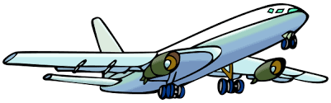

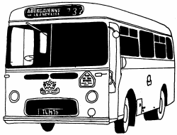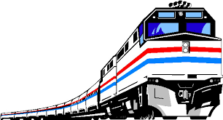

**P R O M E T**

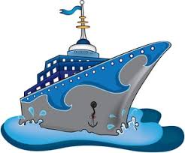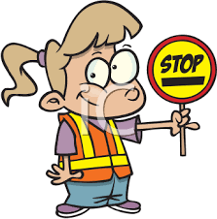PROVJERA ZNANJA

DOPUNI REČENICE!

1. Promet je ____________________________________________________________
2. Vozilima i pješacima kretanje u prometu olakšavaju ______________________________
3. Postoje _________ različite vrste znakova.
4. S obzirom na to gdje se odvija, razlikujemo _____________________________ ,

_____________________________ i _______________________ promet.

........................................................................................................................................................................................

ZAOKRUŽI **DA** ILI **NE** .

5. Znakovi obavijesti zabranjuju zaustavljanje i parkiranje. ........................................... DA NE

6. Ako prelazimo cestu na pješačkom prijelazu, možemo prijeći kad god želimo . ....... DA NE

7. Prometne znakove trebamo uvijek poštovati da bismo bili sigurni u prometu. ......... DA NE

........................................................................................................................................................................................

ODGOVORI KRATKO!

8. U koju skupinu ubrajamo cestovni i željeznički promet?

_____________________________________________________________________________________________________________

9. Što je autobusni kolodvor?

_____________________________________________________________________________________________________________

10. Što treba kupiti prije vožnje autobusom, vlakom, brodom ili avionom?

_____________________________________________________________________________________________________________

11. Što radi kondukter?

_____________________________________________________________________________________________________________

12. Tko upravlja vlakom?

_____________________________________________________________________________________________________________

 ZAOKRUŽI TOČNE ODGOVORE!

13. Prometni znakovi služe: 14. Vlakovi i autobusi voze prema:

a) strancima da upoznaju nove krajeve a) dogovoru vozača i putnika

b) vozačima i pješacima b) voznom redu

c) sportašima c) rasporedu sati

....................................................................................................................................................................................

ODGOVORI KRATKO!

15. Što je zračna luka?

_____________________________________________________________________________________________________________

16. Gdje se sve može odvijati vodeni promet? ( 3 )

_____________________________________________________________________________________________________________

17. Što sve prevoze brodovi i zrakoplovi?

_____________________________________________________________________________________________________________

18. Tko upravlja zrakoplovom, a tko brodom?

_____________________________________________________________________________________________________________

........................................................................................................................................................................................

POVEŽI ODGOVARAJUĆE POJMOVE I OBOJAJ IH ISTOM BOJOM!

ZRAČNA LUKA

SPLIT

MJESTO ULASKA I IZLASKA PUTNIKA

PRIJEVOZ LJUDI I VOZILA NA OTOKE

MORSKA LUKA

SLIJETANJE I POLIJETANJE ZRAKOPLOVA

PISTA

PERON

ZAGREB

TERETNI VLAK

TRAJEKT

PRIJEVOZ TERETA

…………………………………………………………………………………………………………….

**HRVATSKI JEZIK Ovo ne treba slati učiteljici.**

Pročitaj priču DUGA u čitanci, na stranici 144.

Dok čitaš, podvuci imenice u tekstu.